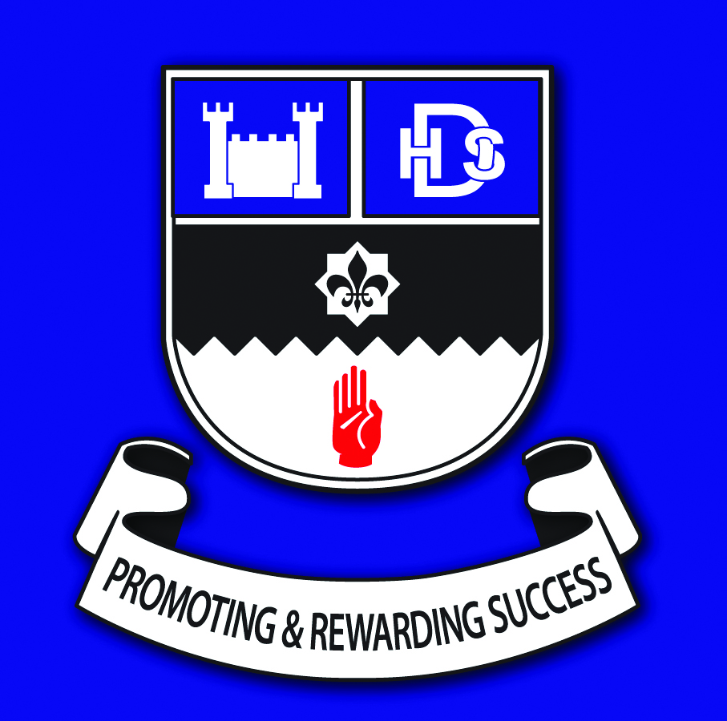 Drumglass High School, Carland Road, Dungannon BT71 4AA 028 8772 2421
info@drumglasshigh.ni.sch.uk
Dear parent 27.3.20
In the light of the current health situation and school closures we are very pleased to be able to offer a continuation of the Independent Counselling Service (ICSS) for schools via the medium of online or telephone counselling.

We recognise that this is an unprecedented situation, but we are fully committed to support the mental health and emotional wellbeing of our pupils. These are unusual times and this brings unusual stressors on young people and their families. There may be anxiety about the lack of exam grades, what will happen in the future, personal health or the health of loved ones. There may be grief over the loss of friendships, routine or people. We want to give a response that is supportive and safe for our young people who are the future of our world. With that in mind let me tell you about the online service.

This is a confidential service for young people who would normally attend school from the ages of 11-18. So every year group in our school, even those who leave school this year can still use it. It happens on the same day and time as counselling is usually delivered in school. If your young person is already receiving counselling, you don’t need to do anything. This will continue via telephone or online. The school counsellor will be in contact with them in a few days.

If you have a young person who wants to refer themselves into the ICSS this can be done through the Familyworks website. The address is www.familyworksni.com . You can also refer your young person to the service but you should get their permission to do so first. You can do this by just asking them privately how they might feel about speaking to the school counsellor. It can help to make sure the young person has a quite space to talk to the counsellor away from the rest of the family. There is a button on the website for parents and school staff to refer.

The service will be delivered to the same standard as in school and will work under the school’s child protection policy so your young person will be kept safe.

A telephone Drop-in will also be provided and the number and time for this will be on the school website.

Finally, if your young person is already receiving help from CAMHS (Child and Adolescent Mental Health Service) that help should continue during this crisis so encourage them to engage with that help. If you feel that your young person is thinking about self-harm or suicide please consult your GP or they can call the lifeline number on 0808 808 8000, or for those who are deaf or hard of hearing 18001 0808 808 8000.

Keep well and keep safe,

M Shilliday
Mrs M Shilliday
Principal

